Simulasi Untuk Suatu Perusahaan Menggunakan Hybrid Network

Raka Yama Putra [1], Gisela Gabriela Juliana Harahap [2], Ghozi Rafi Janitra [3], Anastacia Valentina Sinaga [4]. Desy Anggraini Pratidina [5]

Jurusan Teknik Telekomunikasi, Fakultas Teknik Elektro, Universitas Telkom

Jl. Telekomunikasi No 1, Terusan Buahbatu – Bojongsoang, Sukapura, Kec Dayeuhkolot, Bandung, Indonesia

*Abstract*—Topologi,Jaringan,Hybrid,Simulasi,Cisco Packettracer,VLSM,Switch,Router,Routing Table,IPv4,Subnet Mask,Prefix,Static Routing,DNS,Server. (hybrid

Keywords—component, formatting, style, styling, insert (key words)

I. PENDAHULUAN

**1.1 Latar Belakang**

Hybrid network adalah jaringan berbasis client-server dimana di dalam jaringan tersebut selain server menyediakan kebanyakan sumber yang dibutuhkan oleh user, tetapi user juga masih dapat mengakses sumber-sumber yang disediakan oleh user lain (peer-to-peer) dalam satu workgroup.

# **1.2 Tujuan**

Tujuan dari dari Tugas Besar ini untuk mensimulasikan suatu perancangaan jaringan di suatu lingkup perusahaan dengan mengimplementasikan teknologi jaringan berbasis Topologi Hybrid, sehingga kedepannya simulasi ini diharapkan dapat mempermudah siapapun untuk membangun sebuah jaringan telekomunikasi.

**1.3 Pembatasan Masalah**

Pembatasan masalah pada Tugas Besar ini adalah sebagai berikut:

1.Konfigurasi router menggunakan metode static maupun dinamik

2.Perancangan Topologi Hybrid

3.Manajemen IP Address dengan metode VLSM

4.Konfigurasi DNS Server

**II. DASAR TEORI**

**2.1 Topologi**

Topologi jaringan adalah salah satu aturan bagaimana menghubungkan computer (node) satu sama lain secara fisik dan pola hubungan antara komponen-komponen yang berkomunikasi melalui media atau peralatan jaringan, seperti server,workstation, hub/switch, dan pemasangan kabel (media transmisi data). Dalam simulasi kali ini kita menggunakan Topologi Hybrid yaitu adanya penggabungan dari dua maupun lebih jenis topologi jaringan yang tidak sama. Seperti pada suatu jaringan yang telah menggunakan topologi ring kemudian digabungkan pada jaringan yang lainnya dan menggunakan topologi star. Dengan hal ini maka untuk topologi yang baru telah terbentuk dari hubungan topologi jaringan tersebut.

**2.2 Cisco Packettracker**

Packet Tracer adalah simulator alat-alat jaringan Cisco yang sering digunakan sebagai media pembelajaran dan pelatihan, dan juga dalam bidang penelitian simulasi jaringan komputer.

Di dalamnya kita disediakan beberapa device seperti Router, Switch, HUB, dan END-Device (PC dan Laptop) untuk kita simulasikan. Kita juga dapat mengkonfigurasi router dengan metode static maupun routing dinamik. Pada END-Device kita juga dapat mensetting IP Address, IPV4, maupun IPV6

dengan metode static maupun DHCP.

**2.3 Cara Instal**

Pertama log in jika sudah sudah mempunyai akun Cisco atau sign up untuk membuat akun

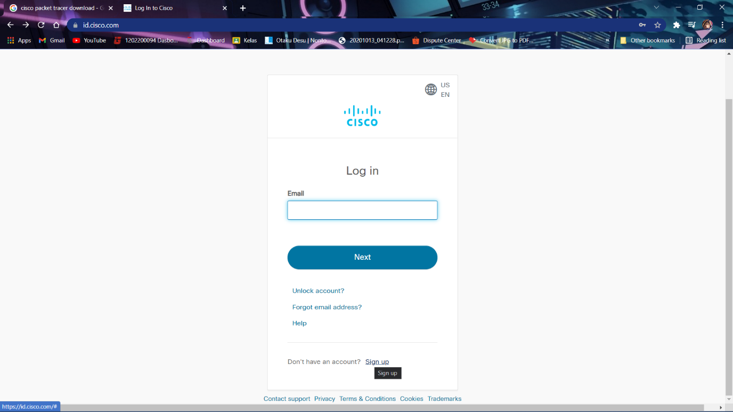

Setelah log in kita dapat mendownload Packet Tracernya di menu resource lalu pilih download Packet Tracer

Lalu kita dapat memilih menginstall Paket Tracer 32 bit atau 64 bit tergantung dengan sistem operasi yang di miliki

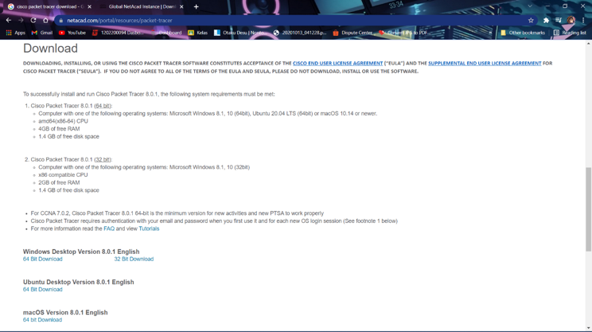

Setelah di download program file nya dapat di buka dan tampilannya akan seperti ini

Kemudian pilih accept the aggrement lalu tekan next

Lalu kita memilih folder tempat penyimpanan paket tracer tersebut lalu tekan next

Setelah itu kita menunggu proses intalasi yang sedang berlangsung hingga selesai

Jika sudah selesai kita klik finish dan mencentang launch Cisco Packet Tracer jika ingin membukanya.

# Kemudian kita diminta untuk login sekali lagi ke dalam akun Cisco

Setelah log in berhasil, Cisco Packet Tracer kita sudah dapat digunakan

# **III. PERANCANGAN**

After the text edit has been completed, the paper is ready for the template. Duplicate the template file by using the Save As command, and use the naming convention prescribed by your conference for the name of your paper. In this newly created file, highlight all of the contents and import your prepared text file. You are now ready to style your paper; use the scroll down window on the left of the MS Word Formatting toolbar.

**3.1 *Setting* IP Berdasarkan Kebutuhan Host**

Setiap Gedung memiliki 2 buah switch cisco dan 1 buah router cisco.

Gedung 1 dan 2 terhubung ke sebuah router cisco sebagai gateway ke webserver.

IP address yang digunakan adalah 192.168.10.0 /24 dengan metode perhitungan VSLM

IP address webserver adalah IP address terakhir yang dapat dipakai di subnet terakhir hasil perhitungan

**3.1.2 Menghitung Subnetting**

|  |  |  |
| --- | --- | --- |
| **Division** | **IP address** | **Subnet Mask** |
| Divisi (A) | 192.168.10.0 /25 | 255.255.255.128 |
| Divisi (B) | 192.168.10.128 /27 | 255.255.255.224 |
| Divisi (C) | 192.168.10.192 /28 | 255.255.255.240 |
| Divisi (D) | 192.168.10.160 /27 | 255.255.255.224 |
| Router 0 – 1 | 192.168.10.240 /30 | 255.255.255.252 |
| Router 1 – 2 | 192.168.10.244 /30 | 255.255.255.252 |
| Router 1 - Webserver | 192.168.10.252 /30 | 255.255.255.252 |
| Available (cadangan untuk penambahan) | 192.168.10.208 /28 192.168.10.224 /28 | 255.255.255.240 |

**3.2 Mengisi IP (Statik) Pada Masing-Masing *End-Device* Disemua Divisi**

Host Divisi A

|  |  |  |  |  |
| --- | --- | --- | --- | --- |
|  | **Gedung 1** | | **Gedung 2** | |
| Division | A | B | C | D |
| PC Host | 64 Host | 28 Host | 7 Host | 16 Host |

**

Host Divisi D

**3.3 Mac *Address Table***

Berikut adalah mac address table yang disimpan (dikenali) switch di berbagai Divisi

**3.3.1 Mac *Address table* di *Switch* 0**

Berikut adalah mac address table yang disimpan (dikenali) switch 0 atau switch pada divisi A dimana didalamnya terdapat mac address dari PC0, PC1 dan router pada Gedung 1.

**3.3.2 Mac *Address table* di *Switch* 1**

Berikut adalah mac address table yang disimpan (dikenali) switch 1 atau switch pada divisi B dimana didalamnya terdapat mac address dari PC2, PC3 dan router pada Gedung 1.

**3.3.3 Mac *Address table* di *Switch* 2**

**Gedung 2.

**3.3.4 Mac *Address table* di *Switch* 3**

Berikut adalah mac address table yang disimpan (dikenali) switch 3 atau switch pada divisi D dimana didalamnya terdapat mac address dari PC6, PC7 dan router pada Gedung 2.

**3.4 *Routing Table***

Berikut ini adalah routing table pada pada setiap router yang berada pada jaringan ini

**3.4.1 *Routing Table* di *Router* 0**

Berikut adalah routing table pada router 0 yang didalamnya terdapat alamat ip yang melewati router tersebut dan terkoneksi langsung. Router ini yang menghubungkan semua perangkat yang ada Gedung 1 (divisi a dan b) dan router 1.

**3.4.2 *Routing Table* di *Router* 1**

Berikut adalah routing table pada router 1 yang didalamnya terdapat alamat ip yang melewati router tersebut dan terkoneksi langsung. Router ini menghubungkan semua perangkat yang ada antara 2 Gedung dan web server.

**3.4.3 *Routing Table* di *Router* 2**

Berikut adalah routing table pada router 2 yang didalamnya terdapat alamat ip yang melewati router tersebut dan terkoneksi langsung. Router ini menghubungkan dengan router 1 dan Gedung 2 (divisi c dan d).

# SIMULASI

**The template is designed for, but not limited to, six authors.** A minimum of one author is required for all conference articles. Author names should be listed starting from left to right and then moving down to the next line. This is the author sequence that will be used in future citations and by indexing services. Names should not be listed in columns nor group by affiliation. Please keep your affiliations as succinct as possible (for example, do not differentiate among departments of the same organization).

### For papers with more than six authors: Add author names horizontally, moving to a third row if needed for more than 8 authors.

### For papers with less than six authors: To change the default, adjust the template as follows.

#### Selection: Highlight all author and affiliation lines.

#### Change number of columns: Select the Columns icon from the MS Word Standard toolbar and then select the correct number of columns from the selection palette.

#### Deletion: Delete the author and affiliation lines for the extra authors.

# PEMBAHASAN

Headings, or heads, are organizational devices that guide the reader through your paper. There are two types: component heads and text heads.

Component heads identify the different components of your paper and are not topically subordinate to each other. Examples include Acknowledgments and References and, for these, the correct style to use is “Heading 5”. Use “figure caption” for your Figure captions, and “table head” for your table title. Run-in heads, such as “Abstract”, will require you to apply a style (in this case, italic) in addition to the style provided by the drop down menu to differentiate the head from the text.

Text heads organize the topics on a relational, hierarchical basis. For example, the paper title is the primary text head because all subsequent material relates and elaborates on this one topic. If there are two or more sub-topics, the next level head (uppercase Roman numerals) should be used and, conversely, if there are not at least two sub-topics, then no subheads should be introduced. Styles named “Heading 1”, “Heading 2”, “Heading 3”, and “Heading 4” are prescribed.

## Figures and Tables

#### Positioning Figures and Tables: Place figures and tables at the top and bottom of columns. Avoid placing them in the middle of columns. Large figures and tables may span across both columns. Figure captions should be below the figures; table heads should appear above the tables. Insert figures and tables after they are cited in the text. Use the abbreviation “Fig. 1”, even at the beginning of a sentence.

1. Table Type Styles

| Table Head | Table Column Head | | |
| --- | --- | --- | --- |
| Table column subhead | Subhead | Subhead |
| copy | More table copya |  |  |

1. Sample of a Table footnote. (*Table footnote*)
2. Example of a figure caption. (*figure caption*)

Figure Labels: Use 8 point Times New Roman for Figure labels. Use words rather than symbols or abbreviations when writing Figure axis labels to avoid confusing the reader. As an example, write the quantity “Magnetization”, or “Magnetization, M”, not just “M”. If including units in the label, present them within parentheses. Do not label axes only with units. In the example, write “Magnetization (A/m)” or “Magnetization {A[m(1)]}”, not just “A/m”. Do not label axes with a ratio of quantities and units. For example, write “Temperature (K)”, not “Temperature/K”.

##### Acknowledgment *(Heading 5)*

The preferred spelling of the word “acknowledgment” in America is without an “e” after the “g”. Avoid the stilted expression “one of us (R. B. G.) thanks ...”. Instead, try “R. B. G. thanks...”. Put sponsor acknowledgments in the unnumbered footnote on the first page.

# KESIMPULAN

The template will number citations consecutively within brackets [1]. The sentence punctuation follows the bracket [2]. Refer simply to the reference number, as in [3]—do not use “Ref. [3]” or “reference [3]” except at the beginning of a sentence: “Reference [3] was the first ...”

Number footnotes separately in superscripts. Place the actual footnote at the bottom of the column in which it was cited. Do not put footnotes in the abstract or reference list. Use letters for table footnotes.

Unless there are six authors or more give all authors’ names; do not use “et al.”. Papers that have not been published, even if they have been submitted for publication, should be cited as “unpublished” [4]. Papers that have been accepted for publication should be cited as “in press” [5]. Capitalize only the first word in a paper title, except for proper nouns and element symbols.

For papers published in translation journals, please give the English citation first, followed by the original foreign-language citation [6].

1. G. Eason, B. Noble, and I. N. Sneddon, “On certain integrals of Lipschitz-Hankel type involving products of Bessel functions,” Phil. Trans. Roy. Soc. London, vol. A247, pp. 529–551, April 1955. *(references)*
2. J. Clerk Maxwell, A Treatise on Electricity and Magnetism, 3rd ed., vol. 2. Oxford: Clarendon, 1892, pp.68–73.
3. I. S. Jacobs and C. P. Bean, “Fine particles, thin films and exchange anisotropy,” in Magnetism, vol. III, G. T. Rado and H. Suhl, Eds. New York: Academic, 1963, pp. 271–350.
4. K. Elissa, “Title of paper if known,” unpublished.
5. R. Nicole, “Title of paper with only first word capitalized,” J. Name Stand. Abbrev., in press.
6. Y. Yorozu, M. Hirano, K. Oka, and Y. Tagawa, “Electron spectroscopy studies on magneto-optical media and plastic substrate interface,” IEEE Transl. J. Magn. Japan, vol. 2, pp. 740–741, August 1987 [Digests 9th Annual Conf. Magnetics Japan, p. 301, 1982].
7. M. Young, The Technical Writer’s Handbook. Mill Valley, CA: University Science, 1989.

**IEEE conference templates contain guidance text for composing and formatting conference papers. Please ensure that all template text is removed from your conference paper prior to submission to the conference. Failure to remove template text from your paper may result in your paper not being published.**